# Biosafety Standards and Ethics Notes

# Food Preservation- Chemical Preservatives with Types, Examples

**Chemical preservatives are intentional food additives incorporated into food to prevent or retard**[**food spoilage**](https://microbenotes.com/food-spoilage-microorganisms/)**caused by microbiological, enzymological, or chemical reactions.**

* These chemical preservatives should be nontoxic to humans or animals.
* Chemical preservatives come under the food additives generally recognized as safe (GRAS).
* Chemical preservatives can also be termed antimicrobials.
* The main purpose of using chemical preservatives is to inhibit the growth and activity of foodborne pathogens and spoilage microorganisms.
* Chemical preservatives used in food can have both bacteriostatic and bactericidal properties per the concentration used.

## ****How food can get chemical preservatives?****

* Intentional addition during food production, processing, or packaging
* Chemical migration from the packaging materials
* Due to a chemical reaction occurring in food
* Residues of pesticides, herbicides, and fungicides on raw food materials
* Migration of disinfectants used on utensils or equipment into foods

## ****Role of chemical preservatives****

* Interferes with the cell wall, cell membrane, enzymatic activity, nucleic acids, etc., to prevent microorganisms’ growth and activity.
* Retard, prevent or control undesirable changes in flavor, color, texture, or consistency of food and nutritive value of food.
* Control natural spoilage of food

## ****Classification of chemical preservatives****

* **Class I:**Traditional preservatives (natural)
* **Class II:**Chemical preservatives (Artificial)

**Class I: Traditional Preservatives:**These include preservatives like wood, smoke, sugar, honey, salt, spices, alcohol, vinegar, vegetable oil, spices, etc which are commonly used in our kitchen in past. These chemical preservatives are not restricted to use and there is no imposed limitation on their use. These naturally occurring preservatives are regarded as safe for human health.

**Class II: Chemical preservatives:** These are synthetic chemical preservatives that are made in the laboratory. For e.g nitrites, propionates, parabens, benzoates, acetates, sorbates, sulfur dioxide, etc.

**Microbial preservatives:**These include antimicrobial preservatives like **bacteriocins** (e.g. **nicin)** which are produced by some strains of lactic acid bacteria and inhibit the growth of food spoilage or pathogenic bacteria. E.g nisin, produced by lactococcus lactis inhibits the growth of Clostridium tyrobutyricum, C. botulinum, and, listeria monocytogenesin cheese, other dairy products meats, fish, etc. Using bacteriocins like microbial preservatives help reduce the use of chemical preservatives like nitrates, sorbates, and benzoates which consumers consider bad.

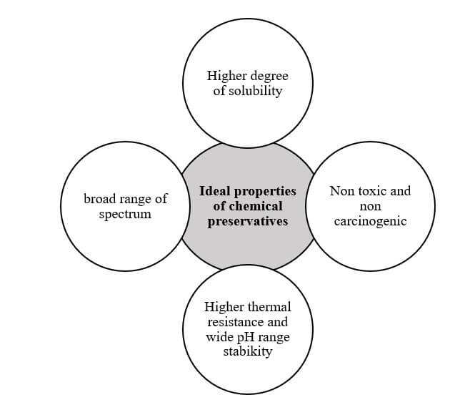

## ****Some food preservatives and their acceptable daily intake****

Chemical preservatives with their ADI quantities (mg/kg BW). E (Europe) number refer to code for substance used as food additives. The E numbers for preservatives range from E200 to E399.

**Table1: According to EU regulation, chemical food additives with their ADI quantities.**

|  |  |  |  |
| --- | --- | --- | --- |
| **S.N.** | **Chemical preservative** | **E number** | **ADI (mg/kg BW)** |
| 1 | Sorbic acid | E200 | 25 |
| 2 | Sodium sorbate | E201 | 25 |
| 3 | Potassium sorbate | E202 | 25 |
| 4 | Benzoic acid | E210 | 5 |
| 5 | Sodium benzoate | E211 | 5 |
| 6 | Parabens | E214-E219 | 10 |
| 7 | Sulfur dioxide and Sulfites | E220-E228 | 0.7 |
| 8 | Potassium nitrite | E249 | 0.07 |
| 9 | Sodium nitrite | E250 | 0.1 |
| 10 | Sodium nitrate + | E251 + | 3.7 |
| 11 | Potassium nitrate | E252 | 3.7 |
| 12 | Acetic acid | E260 |  |
| 13 | Propionic acid and propionates | E280- E289 | 5 |

Source: Adding Molecules to Food, Pros, and Cons: A Review on Synthetic and Natural Food Additives.  Marcio Carocho, Maria Filomena Barreiro, Patricia Morales, and Isabel C.F.R. Ferreira.

## ****Factors affecting the effectiveness of chemical preservatives****

**Chemical preservative properties**

1. Solubility
2. Toxicity

**Microbial factors**

1. Microbial inherent resistance to chemical preservatives
2. Initial microbial load
3. Growth rate and phase of microorganisms
4. Stress reaction of microorganisms
5. Homeostasis ability of microorganisms
6. Use of additional preservative methods

**Intrinsic factors of food**

1. pH of the food
2. Water activity of food

**Extrinsic factors**

1. Storage time and temperature
2. Gas composition
3. Atmosphere and relative humidity

## ****Different chemical preservatives and their application in the food industry****

|  |  |  |  |  |  |  |
| --- | --- | --- | --- | --- | --- | --- |
| **S.N** | **Chemical preservatives** | **Targeted microorganisms** | **Mode of action** | **Advantages** | **Disadvantages** | **Applications** |
| 1 | Sulfur dioxide (SO2) | Yeast, mold | Increase pH and imbalance cellular metabolic process, alter the enzymatic system, | Antioxidant properties, prevent browning, preserve color, cheaper and easily available | The intense pungent odor and corrosive property makes it unuseful in canning | Beverages, fruits products, heat-sensitive foods, effective for low pH foods |
| 2 | Sorbates(Sodium sorbate and Potassium sorbate) | Yeast, Mold, Bacteria | Disturb enzyme system, inhibit many enzymes involved in TCA cycle |  |  | Beverages; juices, wines, cheese, fish meat bakery items, |
| 3 | Benzoic acid and benzoates | Yeast, molds | Disturb enzymatic system | Most active against yeasts and molds. Used to preserve colored fruit juices | Risk of respiratory disease | High acid foods, fruit drinks, cider, carbonated beverages, pickles, jams, salad dressings, soy sauce |
| 4 | Parabens (p-hydroxybenzoic acid) | Yeast, Mold, bacteria | Destroy complex structure of the cell and denature protein inside the cell |  |  | Soft drinks, fish products, salad dressing |
| 5 | Propionic acid | Mold, yeast, and a few bacteria | Disturb enzyme system |  |  | Low acid foods, processed cheese preservation |
| 6 | Nitrate and nitrite | Anaerobic bacteria (Clostridium botulinum), other pathogenic microbes | Inhibit metabolic enzyme | Preserve the color of red meat by forming nitrosomyoglobin | The formation of carcinogenic nitrosamines is triggering extensive research | Used in cured meats, better at low pH foods |
| 7 | Phosphates | More against gram-positive bacteria (Bacillus, clostridium) | Chelating metal ions |  |  |  |
| 8 | Sulfites | More Bacteria, less effective to yeast and mold | Target to the cytoplasmic membrane, DNA replication, protein synthesis, and enzymatic actions | Acts as antioxidants and inhibit enzymatic browning |  | Fruits and vegetable products, wine |
| 9 | Sodium chloride (NaCl) | Bacteria | Osmotic shock to Plasmolysis | Better preservation if used as a pretreatment before canning, pasteurization, or drying | Weak against Staphylococcus and listeria monocytogens | Salting of meats and fish |
| 10 | Wood smoke (Traditional method) | Bacteria, fungi | The release of different phenolic compounds, ketones, aldehyde, and alcohol, which serves as an antimicrobial preservative | Easy to use |  | Meat, sausage, ham, bacon, fish |
| 11 | Nisin | Clostridium botulinum and other bacteria |  |  |  | Cheese, cooked meat, poultry |

## ****The working mechanism of organic acids on the bacterial cell****

Organic acids like Acetic acid, benzoic acid, lactic acid, propionic acid, sorbic acid, etc., are effective as preservatives for foods with a pH of less than 5. So, they are the best for preserving acidic foods.

1. At acidic pH, protonated or uncharged organic acid crosses the cell membrane and enters the cytoplasm.
2. In neutral cytoplasmic pH, organic acids dissociate and release the proton that acidifies the cytoplasm.
3. This cell uses ATP to pump protons out of the cell to deacidify the cytoplasm, which makes energy unavailable for their growth.

**Table: Guidelines for using chemical preservatives in food by DFTQC, Nepal 2075 B.S. (2018 A.D.)**

|  |  |  |  |
| --- | --- | --- | --- |
| **S.N.** | **Food** | **Preservatives** | **PPM** |
| 1 | Sausage meat containing raw meat, Cereals, spices | Sulfur dioxide | 450 |
| 2 | Undried fruits: Cherries, Strawberries, and raspberries.  Other fruits | Sulfur dioxide | 2000          1000 |
| 3 | Concentrated fruit juice | Sulfur dioxide | 1500 |
| 4 | Dried fruits | Sulfur dioxide | 1500 |
| 5 | Apricots, peaches, apples, pears | Sulfur dioxide | 2000 |
| 6 | Sugar, dextrose, jaggery, refined sugar | Sulfur dioxide | 70 |
| 7 | Beer | Sulfur dioxide | 70 |
| 8 | Cider | Sulfur dioxide | 200 |
| 9 | Alcoholic wine | Sulfur dioxide | 450 |
| 10 | Dried ginger | Sulfur dioxide | 2000 |
| 11 | Squash, fruit syrups, barley water | Sulfur dioxide, or benzoic acid | 350 600 |
| 12 | Pickles | Sulfur dioxide, or benzoic acid | 250 100 |
| 13 | Jam, marmalade, fruit jelly | Sulfur dioxide, or benzoic acid | 40 200 |
| 14 | Coffee extract | Benzoic acid | 120 |
| 15 | Tomato or other juices | Benzoic acid | 750 |
| 16 | Pickled meat, bacon, canned meat | Sodium nitrite or potassium nitrite | 200 |
| 17 | Cheese or processed cheese | Sorbic acid or Sodium sorbate or potassium sorbate | 3000 |
| 18 | Paneer | Sorbic acid or Sodium sorbate or potassium sorbate | 2000 |
| 19 | Flour confectionery | Sorbic acid or Sodium sorbate or potassium sorbate | 1500 |
| 20 | Baking flour | Sodium diacetate,  Propionates,  Methyl propyl hydroxybenzoate | 2500  3200    500 |

## ****Do you know?****

* Nitrite and nitrate preservatives should not be used in infant foods.
* The use of titanium dioxide (E171) is fully banned as a food additive in the EU.

**“Preservatives can be used to extend the expiration dates** **of food but unfortunately not of people.”**

# Food Irradiation: Principle of Food Preservation Technique

**Food irradiation is the food preservation technique in which food is exposed to ionizing radiation beams (gamma rays, electron beams, and X-rays) to eliminate food spoilage and pathogenic microorganisms, pests, insects, etc.**

Also, this technique extends the shelf-life of fresh fruits and vegetables by controlling normal processes like ripening, maturation, sprouting, and aging.

The food irradiation process is called cold sterilization (or [pasteurization](https://microbenotes.com/pasteurization-types-process/)) because this process does not produce significant heat; therefore, nutritional and organoleptic properties are preserved compared to other thermal techniques.

The term radiation refers to the number of photons emitted from a single source, while irradiation refers to the process of exposing emitted photons or radiation to the surface.  
A predetermined irradiation dose can be applied to either prepackaged foods (intended for direct consumption) or food in bulk containers.

Irradiated food should be labeled with the international logo mentioning “irradiated food” or “treated with ionizing radiation.”

# 

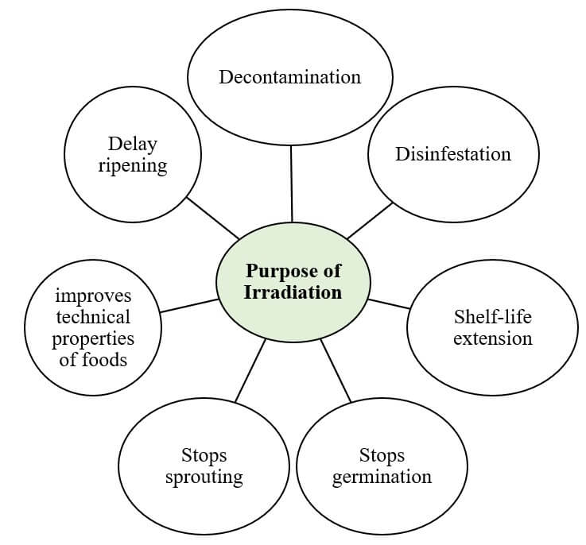

**Purpose of Irradiation**

## ****Significant events in the history of food preservation by Irradiation****

1895 – Discovery of X-rays

1905 – First patent for using ionizing radiation to preserve food

1950 – Research on food irradiation begins

1953 – First commercial application of food irradiation

1958 – FDA approval for using irradiation to sterilize food products

1963 – FDA approved irradiation to control insects in wheat and wheat flour

1980 – CODEX Alimentarius adopts guidelines for the use of irradiation in food preservation

1986 – FDA approved irradiation to control Trichinella in pork products

1990s – EU approves use of irradiation for insect disinfestation and microbial decontamination of spices and herbs.

1990 – Irradiation is approved for pathogen control in Meat and poultry

2000 – approved for shell eggs

2003- WHO and IAEA issue joint statement endorsing safety and efficacy of food irradiation

## ****Radiation dose****

* The quantity of radiation energy absorbed by the food is called radiation dose.
* The unit of radiation dose is called **gray (Gy).**
* **1 Gy** is equal to one joule per kilogram.
* According to CODEX (general standard for irradiated food), the maximum dose delivered to food should not exceed 10kGy.
* The food and Drug Administration (FDA) is responsible for regulating the source of radiation and dose of radiation that are used to irradiate food.
* The use of appropriate radiation doses is the most critical factor in food irradiation.

## ****Different forms of irradiation treatment for sterilization****

1. **Radurisation** (radiate, prolong):  It is a type of radiation treatment in which food products are treated in radiation to increase or prolong their shelf-life during storage maintaining its natural quality. This mode aims to inhibit germination, pest control, slow germination, destruction of pathogenic parasites and microorganisms. This mode applies low dose of radiation.
2. **Radicidation** (radiate, kill):  This radiation treatment involves use of higher dose of radiation to selectively kill microorganisms, such as Salmonella. This technique involves the treatment of food products with dose 2-10kGy, which is technically safe for human health.
3. **Radappertisation**(radiate, canning food): It is a form of industrial sterilization that involves use of highest doses of radiation (10- 50 kGy) to destroy all microorganisms present in the food products. It is specially designed for canned food manufacturers. It is applicable to sterilization of spices, meat products, and dietetic food for sick people.

## ****Three kinds of radiation are used in irradiators****

1. **Gamma-rays from radionuclides 60Co or 137Cs**

* Ionizing radiation emitted from radionuclides.
* High penetration capacity
* Good for industrial scale

1. **Electron beams from machine source**

* Generated from electron accelerators.
* Low cost
* Have a maximum penetration depth of up to 8 cm only.
* Applied to the food surface spread in a thin layer.

1. **X-rays from the machine source**

* Generated from an X-ray generator.
* Good penetration capacity as compared to electron beams.

## ****Factor affecting food irradiation treatment.****

* Type of food
* Radiation dose
* Treatment plant design
* Exposure time and temperature

## ****Features of food Irradiation****

* Cold sterilization
* Effective in lengthening the shelf-life of fresh fruits and vegetables.
* Green technology
* Nutritional stability of irradiated food
* Minimal loss in texture, flavor, aroma, and color of food
* It does not make food radioactive.

## ****Principle of food irradiation****

* Machines, principally electron accelerators, X-ray generators, or radionuclides, were designed to generate safe ionizing radiation.
* Accelerated electron beams can penetrate food (up to 8 cm)
* **Direct effect**: When electromagnetic radiation or particle beams directly strike a molecular complex in biological material, altering or destroying its biological function which can lead to chromosomal disorders or mutations. However, direct effect is considered less important in food preservation.
* **Indirect effect**: Ionizing radiation activates atoms in high moisture foods, producing free radicals through the radiolysis of water. Highly reactive hydrogen (H.) and hydroxyl (OH.) radicals are produced, which combine to form hydrogen, hydroxy, and hydroperoxyl radicals. Oxygen participates in the reaction to form hydroperoxyl radicals, which play a major role in microbial inhibition through their oxidative effect. These free radicals interfere with biochemical reactions and alter molecular structure, including breaking single and double-stranded DNA molecules by abstraction of hydrogen and elimination of phosphate, as well as hydroxylating purine and pyrimidine bases.

## ****Application of Irradiation in Foods****

* delays the ripening of green bananas.
* Inhibit sprouting of potatoes and onions.
* prevents greening of potatoes
* softens legumes and shortens their cooking time.
* increases yield of juices from grapes
* The speed drying rate of plums.

|  |  |  |
| --- | --- | --- |
| **Dose range (kGy)** | **Application on food products** | **Objective of irradiation** |
| 0.05 – 0.15 | Potatoes, onions, garlic, yams | Inhibition of sprouting |
| 0.1 – 0.3 | Meat | Destruction of parasites |
| 0.1 – 0.5 | Grains, flour, coffee beans, dried fruits | Insect disinfestation |
| 1.0 – 5.0 | Fruits and vegetables | Reducing of microorganisms |
| 0.5 -1.5 | Mushroom, fruits | Delay maturation |

## ****How is food irradiated?****

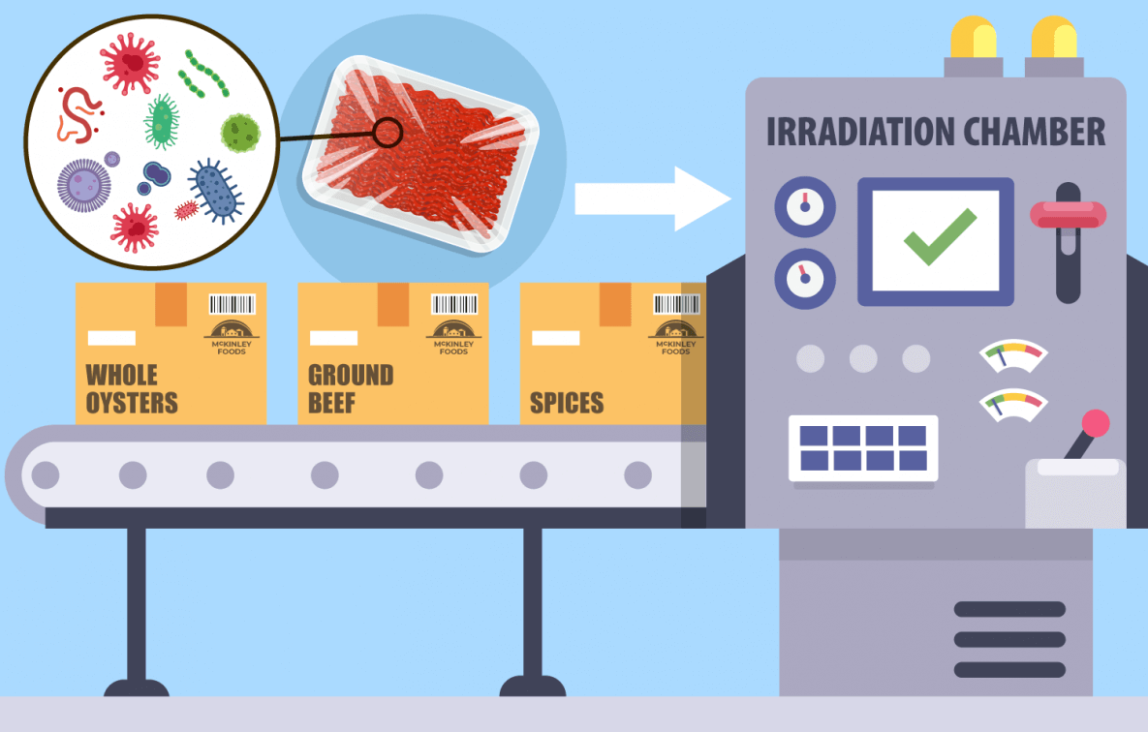

How is food irradiated? Image Source: [CDC](https://www.cdc.gov/foodsafety/communication/food-irradiation.html).

## ****Disadvantages of Food irradiation****

* High initial cost
* Public perception
* Changes in sensory properties
* Regulatory issues
* Limited effectiveness against certain microorganisms
* Risk of unintentional over-irradiation
* Irradiation-resistant microorganisms can produce toxins.
* The potential for the formation of harmful by-products

**Irradiated food must be labeled with the following symbol called Radura**.

Radura Symbol